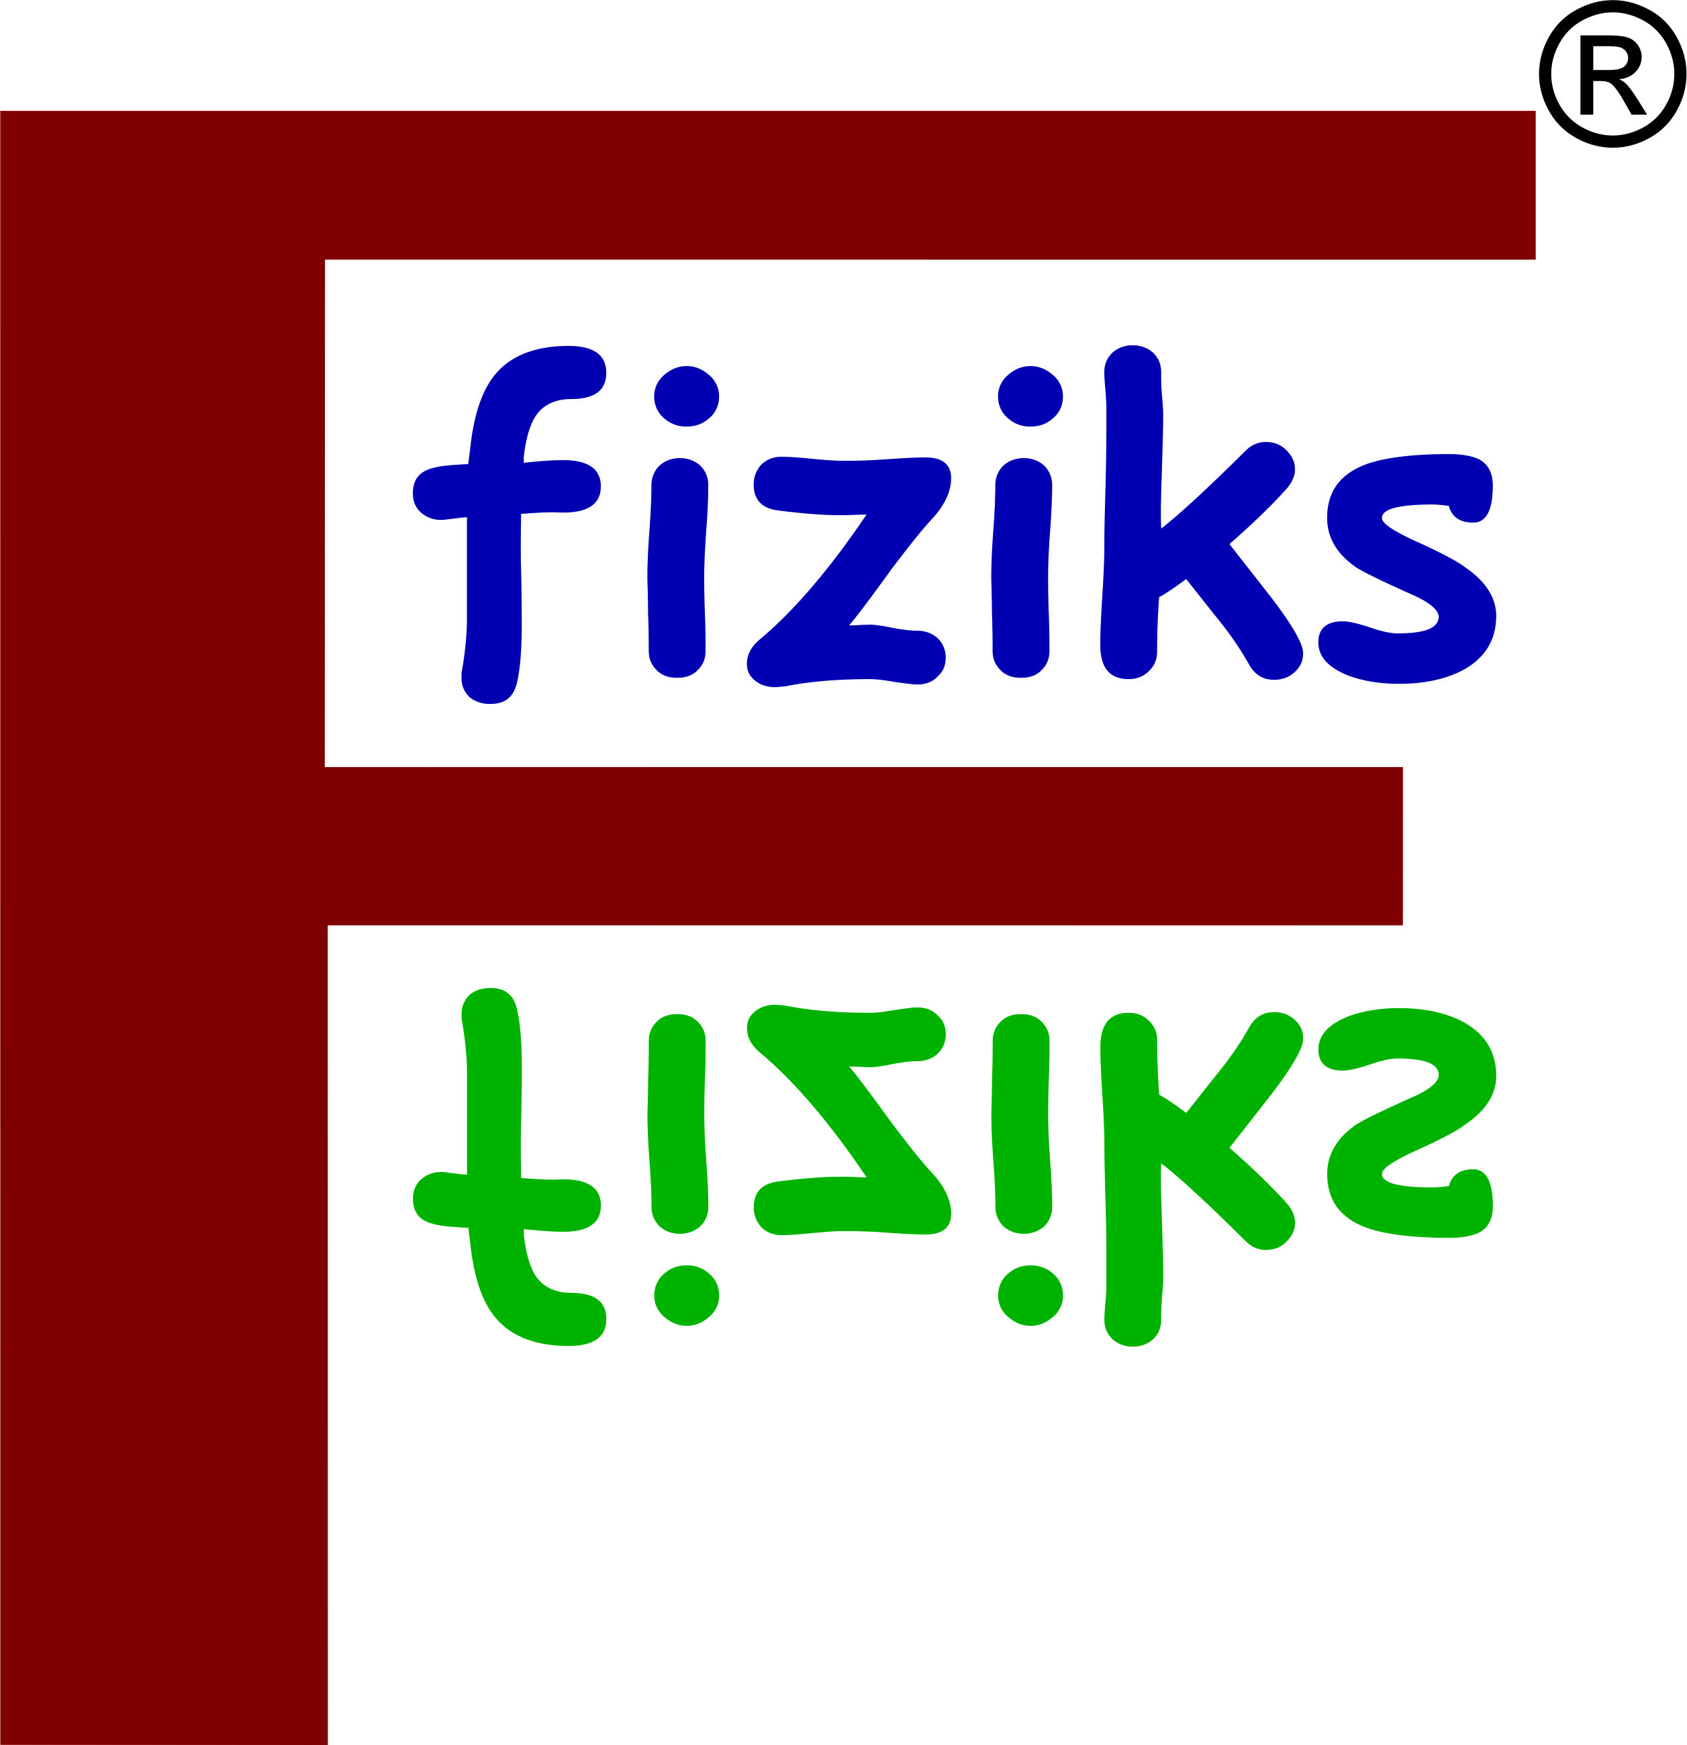
fiziks

Student
Photo
An Institute for Physical Sciences

Name of Student _________________________Student's Mobile No. ____________________
Date of Birth ______________________ Gender M F
Father's Name ___________________ Parent's Mobile No. ____________________________
Mother's Name _________________________________________________________________
Permanent Address _____________________________________________________________
_______________________________________________________________________________
Guardian's Name _________________________________ Mobile _______________________
Local Address __________________________________________________________________
E-mail _________________________________________________________________________

CSIR-NET Courses |  | IIT-JAM Courses
Online  Regular  Pre-Recoding  Correspondence  Test Series  Topic Wise | NET-JRF  GATE  JEST  TIFR  Other | Online  Regular  Weekend  Pre-Recording  Correspondence  Topic Wise  Test Series | IIT-JAM/IISc  JEST  GATE  TIFR  JNU  CUET  Other

Educational Qualification

Exam | University | College | Year of Passing | Percentage
Graduation
Post Graduation
Others

Fee Card [Fee Includes 18% GST]
 | 1st Installment | 2st Installment | Note:  One Time Payment for Pre-recording and correspondence student.
Amount
Due Date

UNDERTAKING FROM THE STUDENT

This is to be stated that I ________________________ son/daughter of ________________ resident of _________________ am joining fiziks institute have complete knowledge of the institute and of its rules and regulation as mentioned in the information bulletin or on its official website (www.physicsbyfiziks.com).
I declare that I will abide by the rules, regulation and discipline of the institute. In case of violation of discipline and non seriousness towards study, I can be terminated from the institute without any claim for the refund of fees. For any disciplinary action the decision of managing body of the institute will be final. I am aware of the fact that fees once submitted to the institute will not be refunded.
The institute has sole authority to publish the result on its website, booklet and public hoarding. I have no objection on it.

Date: _______________ Signature of Candidate

FOR OFFICE USE
Date of Admission __________________ Enrollment No. _______________ Batch ____________

